Peer to Peer Digital Market

John Wensink

MIS300 Information Systems Design and Management

Colorado State University-Global Campus

Nathan Braun

January 8, 2019

Peer to Peer Digital Market

In the ’90s the world learned how to be connected when the internet was born. A whole new industry of-of e-Commerce saw limitless potential when suppliers and consumers were able to come together on through a third-party website.Now, in 2019, it is finally time to cut out the middleman. When buyers and sellers are able to connect to each other in real-time, they will wonder why they ever paid a website service fees in the first place. The role of e-commerce in modern global society has grown at an astounding pace. As it stands today, buyers and sellers rely on intermediary websites like eBay or Amazon to buy and sell. A peer-to-peer (P2P) model is more economical for all parties involved, and the infrastructure already is largely already in place. What would it take for myself and a small team of specialists to design an e-commerce platform that is hosted entirely as a peer to peer network on the end user’s computer as a software program? I envision an e-Bay or Amazon-style user-interface where people can buy and sell their new and used items, but the difference being there are no sellers fees, and the platform’s content is not stored on a server in a traditional sense, but rather locally, encrypted in the end user’s hard drive. Another big difference is that this company’s profit model will not be based on seller’s fees but rather value-added processes that allow large sellers conveniences of scale. Areas of focus must include the organization’s business model, market share and competition, as well as issues concerning our customer base. Steady access to revenue is a factor in all emerging businesses and ours is no different. Our company can provide our users with a suite of services including store templates, bulk shipping, and backup content hosting.

**SCM/CRM**

Supply chain management is an area where I think this novel approach to e-commerce will be of great benefit, as this will open up a new market to the farthest reaches of global society. People who have been discouraged from using the web to sell their products by high seller fees are our target market. With no overhead cost related to our marketplace, a seller is now free to market their products at a fair price which is more likely to attract customers. This would be a true free market economy. Another area of focus for our business must be customer relationship management or CRM. It is critical that the end users (buyers and sellers) find the platform streamlined and straightforward to use with a visually appealing user interface. So much that it is as convenient and intuitive to use as the current frontrunners in the e-commerce industry. My role in this startup is the owner of the company. It is my responsibility to implement my strategic vision, and lead all aspects of that vision’s implementation including the onboarding of technically proficient employees who will excel at designing the highly specialized aspects of electrical, database, and data engineering. I will outsource these areas to the skills of highly talented student colleagues, who have the skills needed to disrupt a multi-billion dollar global industry, and are becoming experts in their respective fields of “eCommerce presence, database systems, security policies, continuity planning, and customer privacy.” (CSU-Global, 2018)

**Business Model**

The landscape in today's consumer marketplace is trending broadly towards digitized e-commerce. Websites like Amazon, eBay, and Alibaba make it so easy to shop online that virtually any item can be ordered and shipped to your door with just a few clicks. There are some downsides to this traditional type of platform which include high sellers fees, security of information, and difficult-to-use customer support. Our P2P, open source model aims to attract market share by addressing these issues. Another issue that is rarely talked about is the push for digital virtual assistants being paired with e-commerce websites and the big data privacy issues that come with it. Devices like Amazon’s Echo and Google’s Home can make life more convenient for a home shopper but also opens up that shopper to a slew of security considerations by putting a live microphone in any room of your house. Many people have noticed the big data initiatives by many companies and a seed of distrust has been sewn. In a locally hosted P2P market the shopper owns all his own data and chooses what gets published and collected. Advertisement revenue would not exist in this marketplace. A core principle of this company is the individuals right to their own data. Any revenue stream must not exploit the digital footprints of our clients for the company’s gain. A decentralized hosting environment allows access to other areas of revenue such as large business scaling services as well as optional backup hosting services. Our revenue won’t come from ad’s or commisions, and our profit model won’t be huge like the traditional platforms. Rather this will be a sustainable e-commerce utility that will allow global access to a unique variety of products sourced at a fair price to all due to the complete lack of fees typically associated with such a platform.

In his 2018 textbook, Satir lists several strategies that should be implemented in order to help your company build market share.

* Demonstrate a strong desire to build an ongoing relationship with customers by giving first-time price incentives, offering loyalty programs.
* Make it clear that considerable investment has been made in the web site.
* Provide brand endorsements from well-known experts or well-respected individuals.
* Demonstrate participation in regulatory programs or industry.
* Display Web site accreditation by the Better Business Bureau Online or TRUSTe programs. (Satir, 2018)

**Funding**

Today, there are several venture capital companies investing in forward-thinking startups that aim to reach the global economy through unique web applications, one of which is USV, or Union Square Ventures. USV invests in disruptive companies like Flip, which allows users to get in or out of apartment leases, ShopShops which connects physical businesses with overseas customers, and Dapper, a blockchain based gaming service. Based on USV’s Thesis III published in April the investors state they are looking to:

Invest in large networks of engaged users, differentiated by user experience, and defensible through network effects. This post breaks down the components, but the crux of this thesis involved primarily consumer-focused businesses where the value of the service to a user increases as others use it, too. These network effects create defensibility and lead to scale. (USV, 2018)

This is our business model verbatim. The more users we are able to attract, the more robust experience the platform will be. I envision a program where consumers are able to shop a global marketplace of uniquely local items that are otherwise highly marked-up or rare to be imported in mass. The sellers using this service will include people from the global community regardless of existing trade relationships. As a business, we must expect our user base to come from countries who are less familiar with the modern global e-commerce marketplace. It is because of this that ease of use must be a top priority. To that effect, USB thumb drives with our software package will be available for mass distribution free of charge, and the software will be freely available on our company website. Our software package will consist of a server side and a client side database management programs both of which are fundamentally open-source software.

“The Open Source Definition is the definition propounded by the Open Source Initiative, used to describe which licenses qualify as "Open Source" licenses. Open source licenses must permit the nonexclusive commercial exploitation of the licensed work, must make available the work's source code, and must permit the creation of derivative works from the work itself. (St. Laurent, 2008)

The benefits of doing this project open source are that we can crowdsource development and maintenance out to highly skilled individuals, making the whole world our development lab. Other benefits to open source software include “lesser hardware costs, higher-quality software, no vendor lock-in, integrated management, lower software costs, and abundant support.” (Outsource2india, n.d.)

If our platform is widely distributed, and easy to use, “supply chain management” (SCM) will take care of itself. Artisans, farmers, and entrepreneurs across the world will find they have a new market to sell their goods where none existed before, or the fees to access such a market were prohibitively high. A wide variety of locally and globally procured items will become available to shoppers, and the variety of items offered will grow larger with more and more user involvement. The key to this is “customer relationship management” (CRM) and this includes both buyers and sellers. The platform must be so simple to use that a farmer in the third world must be able to plug in his USB at an internet cafe and have access to his store on the P2P network, be able to manage his sales and receive payment for his work. There are many aspects of CRM to which critical attention must be paid:

organizations need to focus on three types of knowledge in CRM processes. Firstly, they need to understand the necessities of customers in order to address them. Secondly, the information needs of the customers in their interaction with the organization require knowledge for customers. Thirdly, customers possess knowledge about the products and services they use as well as about how they distinguish the offerings they purchased. This knowledge from customers is valuable as it feeds into measures to enhance products and services (Singh, 2011)

To this end, our business must offer broad CRM support in the form of a self-help community that is modeled after the Community Support webpage for the Ubuntu operating system (Canonical, 2018). Here users from around the globe can ask and answer questions on a broad range of topics. The community has developed into a huge database for knowledge, and with time our company’s community will also grow. If our community of users grows large enough, we could disrupt the traditional e-commerce industry that is quickly becoming the preferred medium of human international trade. A key component to generating significant market share is a strong mobile presence.

**m-Commerce**

The number of smartphone users on Planet Earth is set to exceed 2.87 billion users by the year 2020. (Statista, 2018) It will be critical in this endeavor to take advantage of the huge revenue stream that is mobile e-commerce. As it stands today, many buyers and sellers rely on intermediary websites like eBay or Amazon to do business. The prosperity of this endeavor will be directly correlated to the degree of success with which we implement a P2P m-Commerce application that is secure, easy to use, and wildly distributed. Smartphone access is proliferating at a steady rate and this trend is expected to continue into the next decade with major providers already rolling out their 5G network infrastructure. Although not required, 5G networks high bandwidth availability will be the key to maintaining P2P uptime. Having a network that is able to provide 5G connectivity will give a competitive advantage to subscribers in fully developed countries. Our company’s mission is to provide this access to parts of the world without such infrastructure, giving power to the individual. As such, it is imperative for our company’s service to be fully compatible with 3G networks either thru simplicity, or a separate “lite” app. The maps depicted below show the development of mobile network infrastructure across the globe. While there is global coverage for basic GSM networks, this level of bandwidth is not sufficient. The Middle map shows 4G/LTE coverage in dark green, 3G service in light green, and GSM only in orange. The bottom map shows areas where 5G networks are currently undergoing testing in purple, and 5G R&D hubs shaded blue.

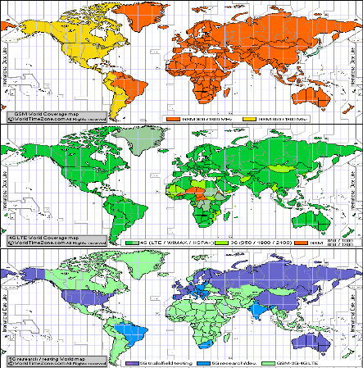

(Worldtimezone, 2018)

Our company’s primary mobile app should be designed to run on 4G/LTE networks, with future plans to develop a more robust app for when 5G arrives in the mainstream. Conversely, for truly global coverage, a 3G Lite app should be considered for the parts of Africa and Central Asia that lack 4G infrastructure, and users trying to use less data in general. Cloud storage will need to be used in order to host the files required as physical memory on mobile phones will certainly be of insufficient volume to contain all the required files

**Competition**

Our company is not the first to implement a peer-to-peer e-commerce program, but perhaps we could be the best. The desktop application “OpenBazaar” came onto the scene in 2016. OpenBazaar, so far, has failed to gain significant traction in the e-commerce sector. OpenBazaar uses the digital cryptocurrency Bitcoin, which is simply an encrypted ledger of accounts, or wallets. Bitcoin has been associated with cybercrime and many individuals are hesitant to adopt it. Although useful for circumventing oppressive regimes, developed EFT infrastructure makes Bitcoin is practical if you are trying to obfuscate your financial details. There are a number of legitimate reasons why somebody would legitimately want to hide their store’s paper trail. For example, it is illegal to send more than $50,000 per year out of China. For this reason, it is recommended that your company process transactions using the traditional credit card processing systems that are commonplace today. We recommend augmenting this with new P2P payment systems such as Zelle or Venmo. It is wise to make Bitcoin available for those who wish to use it while keeping in mind that the use of this currency has historically been put to nefarious use.

**Network Security**

Suppliers and consumers need to feel secure using our platform. The exchange of value will be highly targeted. How will your company provide security to its users in today’s cybercrime environment? The website hackmageddon.com (2018) provides a statistical analysis of emergent trends in cyber attacks. 2018 has trended higher in the volume of attacks every month this year except for August, which seems to represent a confidence floor. 2019 is forecasted to continue trending higher as IoT starts to become a mainstream reality.

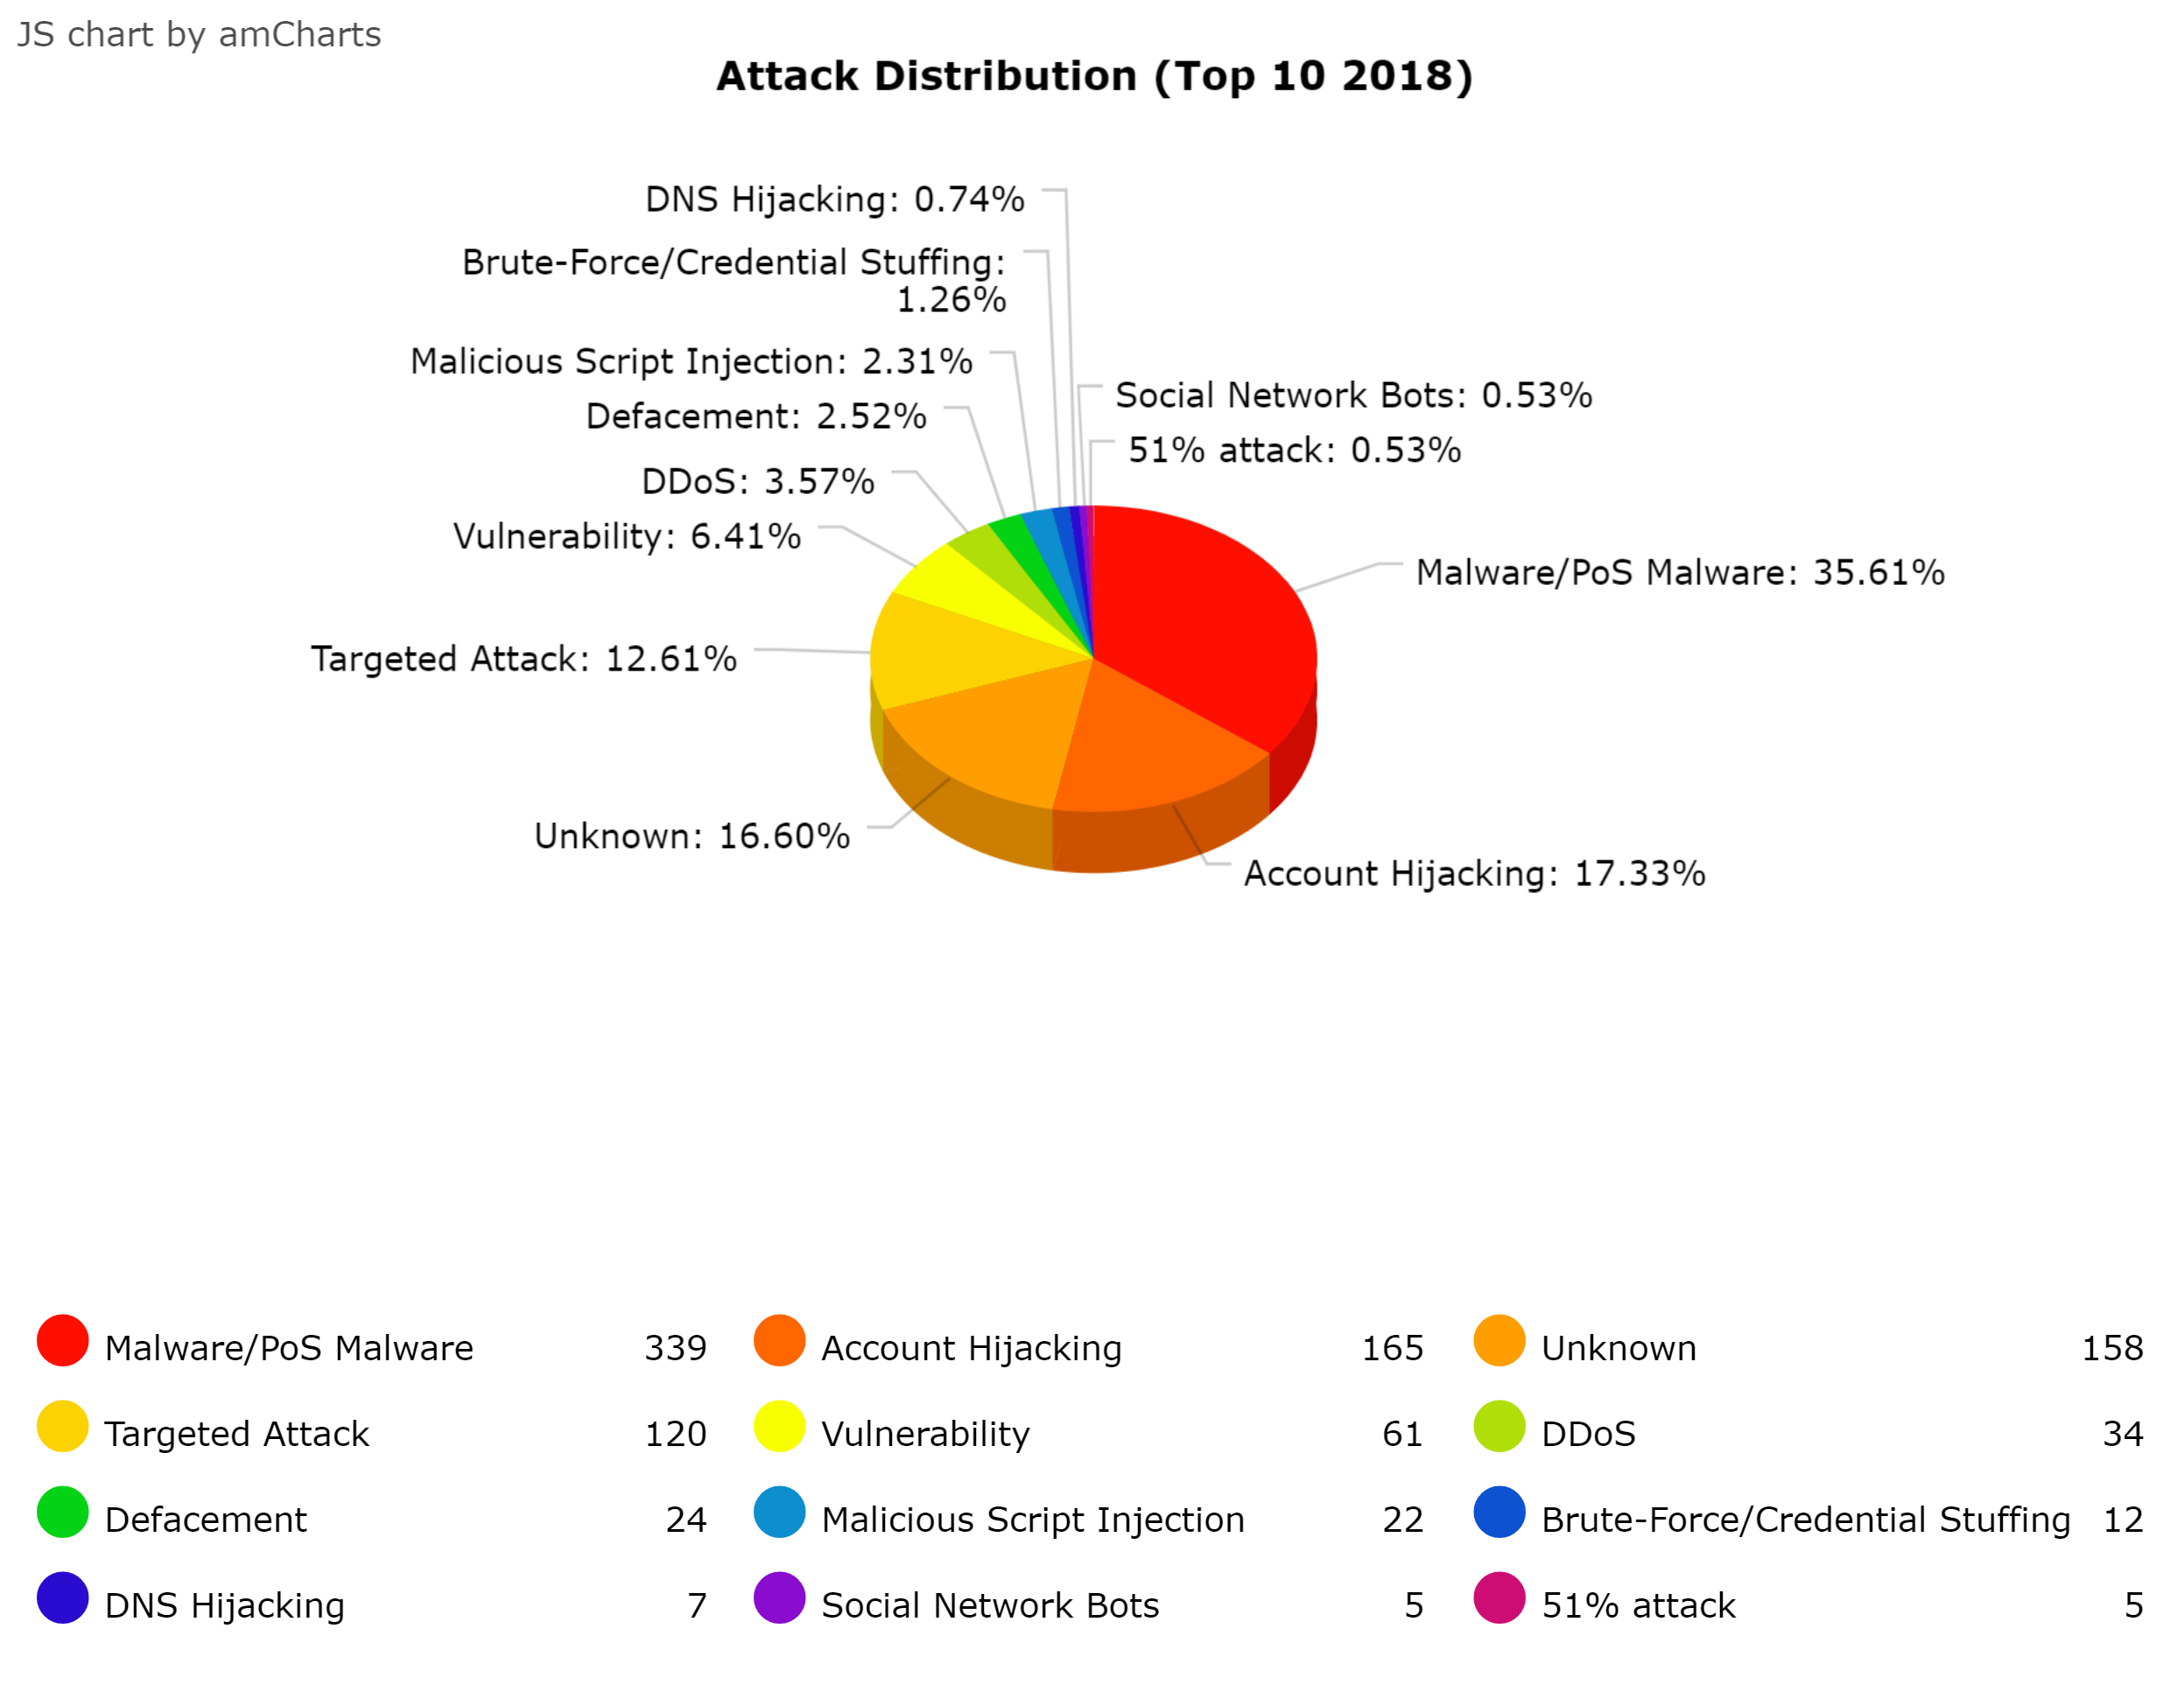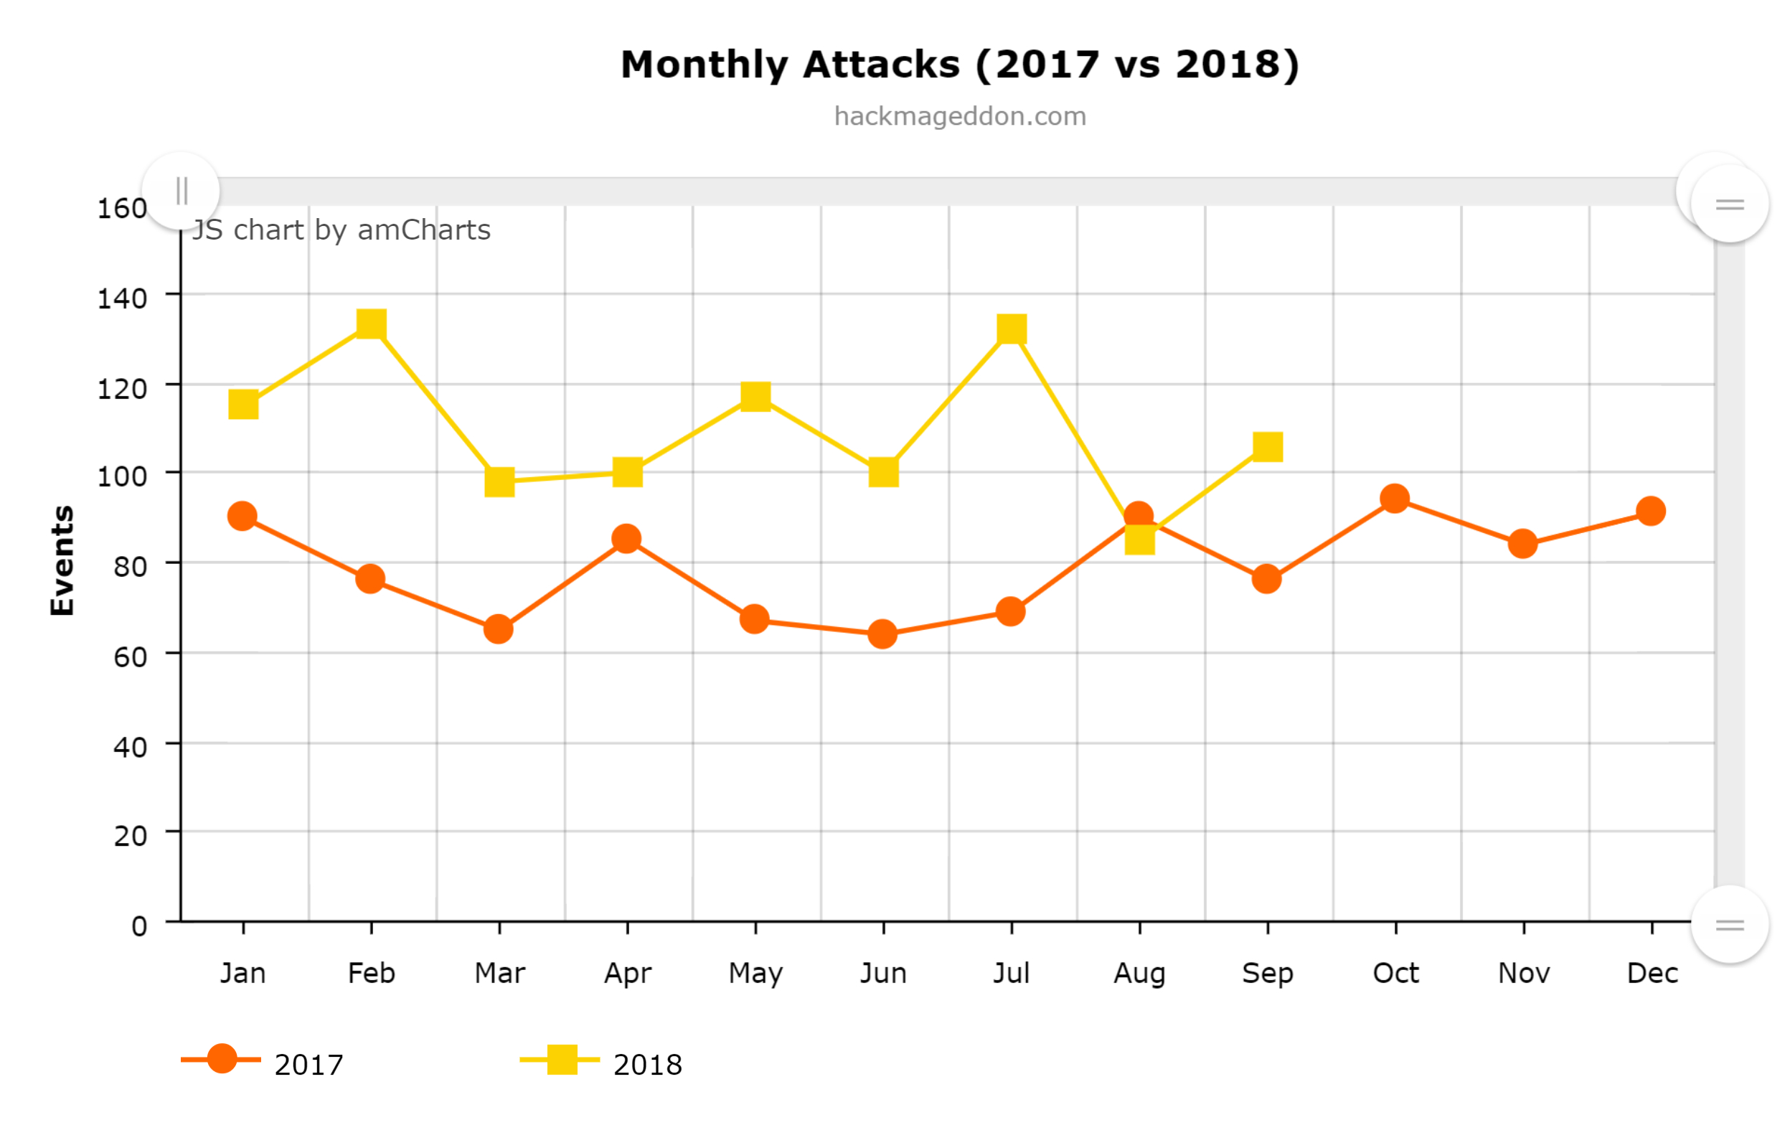

(Hackmageddon.com, 2018)

In addition to partnering with a traditional network security firm, such as Norton, or Symantec. It is also in your company’s interest to take advantage of the revolutionary advances that are occurring in the field of collective information security. Peer-to-peer networks offer distinct advantages to detecting malicious operations.

A collaboration of defensive network components of multiple operators is a promising approach for increasing anomaly detection accuracy. This concept involves sharing of possibly sensitive data, hence privacy preservation has to be taken into account. Common approaches for sharing traffic information often impede proper analysis due to privacy-preserving mangling operations, and ignore the opportunity to exploit additional knowledge of the originating network operator for interpreting the monitored data. (Berger et.al., 2011 p.1)

P2P networks can provide other advantages to the end user’s network security. Recently, a new service has appeared in the information security landscape called Levelnet.

LevelNet is a cyber-security software designed to provide unseen-before protection level to any internet user. Once installed on the device it forms peer-to-peer network and combines all cyber-security resources available in the network to protect a single user. LevelNet designed to be installed on billions of devices, making every individual user invulnerable to viruses and other malware. (Levelnet, 2018)

Implementation of a collective P2P anti-malware system is a revolutionary idea that should be implemented into the software distribution. This will provide a wide range of malware protection from threats such as viruses, worms, trojan horse vectors, rootkits, ransomware, and keyloggers. This technology is in its infancy and should not be expected to resolve all threats to information security. Traditional security methods should still be implemented, with Levelnet being an additional layer of safety. One should look to the banking and medical professions for ideas for technical safeguards for our project. Resources such as multi-factor authentication, biometric security, and a strong password are just the beginning. HIPPA, the laws that protect one’s medical information gives some other ideas such as implementing a security management process, assigning security responsibilities to staff members, maintaining a secure workplace, limiting access to information, implementing a security awareness training program, having established security incident procedures with a contingency plan for when there is trouble, as well as regularly auditing security logs. (HIPPA, 2019)

**Contingency Plan**

It is prudent to plan ahead for when disaster strikes, this applies to every e-commerce business in existence. Having users information stored locally on their own devices will go a long way in preventing a single attack from taking down the whole network. With every user storing a complete backup of the platform that refreshes and rewrites the data at a set interval, it would be more difficult to take down the network as a whole. Still, backups of critical admin data are paramount. This backup should be stored in a way that it is never connected to the external internet, and encrypted so that admin’s private keys are required to access the information. Any good contingency plan must first identify the risks that are possible, yet unpredictable in the wild. This could include malicious actors, natural disasters, sudden changes to staff, sudden changes in cash flow, as well as more generalized events such as internet service providers going down. However unlikely an event is to occur, it must still be considered and ranked in order of likelihood of occurrence, and severity of damage. The highest priority threats should be addressed first and with the most resources. A formal contingency plan shall be drafted which will read like a checklist of tasks to complete that will mitigate the damages associated with the catastrophe. On the checklist, several key steps must be included such as who to contact, contact information, flow charts that itemize things such as duration of the event, the scope of the event, as well as specific tasks for staff to complete depending on the flow of events. Being that this platform has never had any substantially similar history to draw experience from, it is possible that gaps in continuity will exist. Our organization must have an information security officer in charge of growing and maintaining our contingency plan for the unknown unknowns that are likely to become apparent one business starts.

**Conclusion**

A Peer-to-Peer digital marketplace could revolutionize the way that e-commerce takes place in our modern world. This idea will require several cooperating components to be successful such as supply chain management, customer relationship management, the free availability of our software, funding, and developing the mobile app. There are security threats at every step that must be acknowledged and mitigated. Fortunately, the P2P nature of our marketplace, combined with hosting data locally on the users' device will help with many threats, but not all. Partnering with established firms like Norton, Symantec, and Levelnet will provide additional protection for our users that could not otherwise be provided. We will partner with traditional payment processing systems such as Visa and Mastercard, while also allowing for the use of digital currencies such as Bitcoin to be used for value transfer. This endeavor will live or die based on the number of active users, and the uniqueness of the products available for sale. In order to disrupt the major players already established in the industry, there needs to be a visually appealing and functional user interface. If this succeeds, it will transform the e-commerce for the better with buyers and sellers no longer having to pay fees to gain access to the free market.

References:

Berger, A., Ceseareo, J., & D'Alconzo, A. (2011, December). Collaborative Network Defense with Minimum Disclosure. Retrieved December 16, 2018, from <https://ieeexplore.ieee.org/document/6133889>

Canonical. (n.d.). Community support. Retrieved December 9, 2018, from

<https://www.ubuntu.com/support/community-support>

Department of Health and Human Services. (2007). HIPPA Security Series #4. Retrieved January 11, 2019, from <https://www.hhs.gov/sites/default/files/ocr/privacy/hipaa/administrative/securityrule/techsafeguards.pdf?language=es>

Hackmageddon. (2018, October 15). 2018 Master Table. Retrieved December 16, 2018, from <https://www.hackmageddon.com/2018-master-table/>

Levelnet. (2018). Collective Information Security. Retrieved December 16, 2018, from <http://www.levelnet.co>

North Carolina State University. (2017, April 02). Supply Chain Resource Cooperative. Retrieved December 16, 2018, from <https://scm.ncsu.edu/scm-articles/article/what-is-supply-chain-management-scm>

Outsource2India. (n.d.). Outsource Services Home. Retrieved December 9, 2018, from <https://www.outsource2india.com/software/articles/open-source-software.asp>

Stair, R. M., & Reynolds, G. W. (2018). Fundamentals of information systems (9th ed.). Boston, MA: Cengage Learning. ISBN: 9781337097536 Retrieved December 16, 2018

Singh, Ramjanm. (2011). A Proposed Model for Integration of ERP, CRM, SRM and Supply Chain Management. Retrieved December 9, 2018, from<https://www.researchgate.net/publication/262936402_A_Proposed_Model_for_Integration_of_ERP_CRM_SRM_and_Supply_Chain_Management>

St. Laurent, A. (2008). Understanding Open Source and Free Software Licensing. Retrieved December 9, 2018, from<https://books.google.com/books?id=04jG7TTLujoC&pg=PA4#v=onepage&q&f=false>

Statista. (n.d.). Number of smartphone users worldwide 2014-2020. Retrieved December 16, 2018, from <https://www.statista.com/statistics/330695/number-of-smartphone-users-worldwide/>

USV. (2018, April). USV Thesis 3.0. Retrieved December 9, 2018, from<https://www.usv.com/blog/usv-thesis-30>